Procedural Content Generation Assessment Item 1 Report

**Development Log**

The first part of the assignment I decided to tackle was the landscape elements, starting with creating the galaxies to fill the background of the diorama, which was simply black in colour. Following the workshop 8 tasks, I created a single galaxy for the background of the scene, I then added randomness to the constant variables of the equation to add variance to each distant galaxy generated. These galaxies are placed by randomly spawning them onto a large sphere collider that is situated in the middle of the game world. I then added an emissive material and applied random colour values to the galaxies, I also applied a rule that makes stars, closer to the centre of the galaxy more brighter (See Figure 1). This turned out to not be as effective as predicated due to bloom’s reliance on distance and the angle of the object.

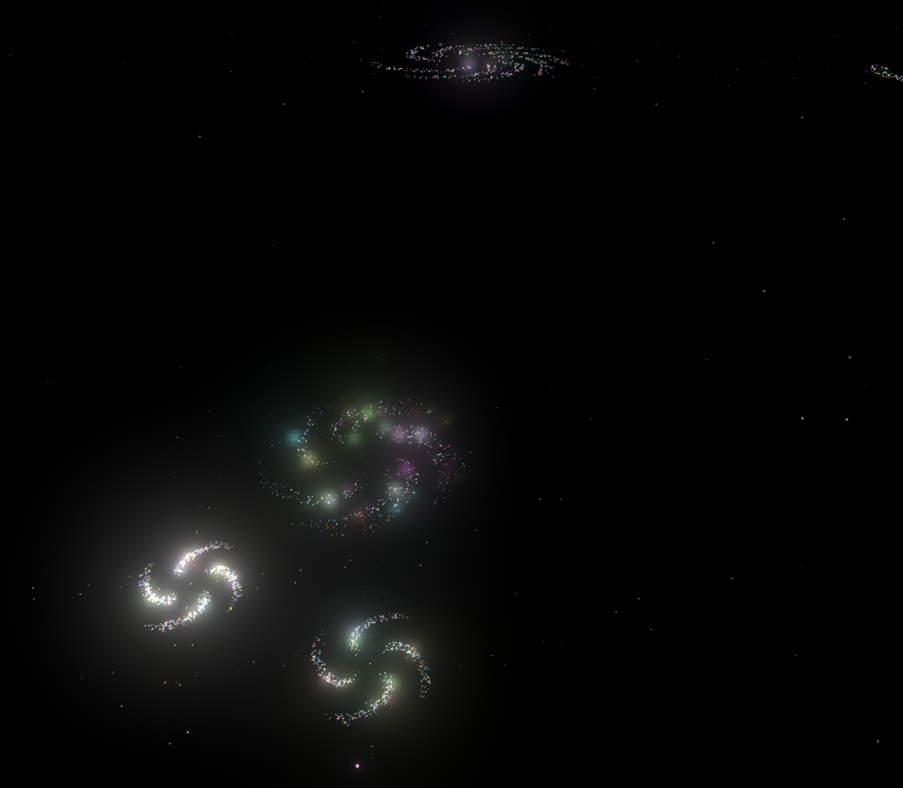

*Figure 1: Procedural distant galaxies being spawned around the diorama.*

With the diorama now having a functional background, I moved onto the spawning of the solar system and its planets. The star was simply generated at the centre of the game world, which is given a random size attribute, the scale of the star determines what colour it will result in being. Past the scale threshold the star has a much higher chance to spawn with a warmer colour set, similar to red giant stars and being below the threshold results in the star using cooler colours (See Figure 2).

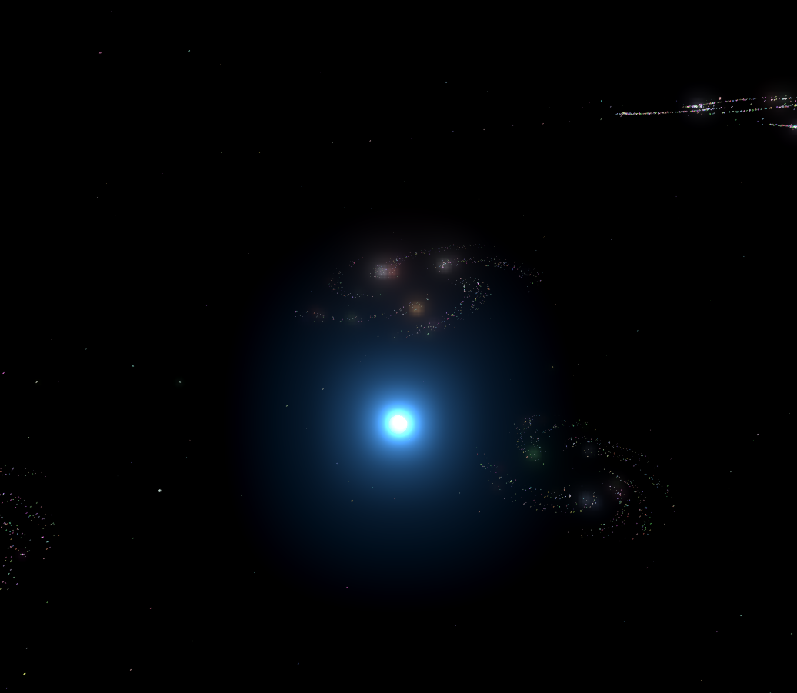

*Figure 2: A small star (with cooler colours) generated in the diorama.*

For the placement of planets in the solar system I used the polar coordinates system described in the lecture 8 slide materials. This works by placing one planet after the other with differing minimum and maximum spawn values based on the previous planet, this ensures that the planets will never intersect when orbiting around the star (See figure 3).

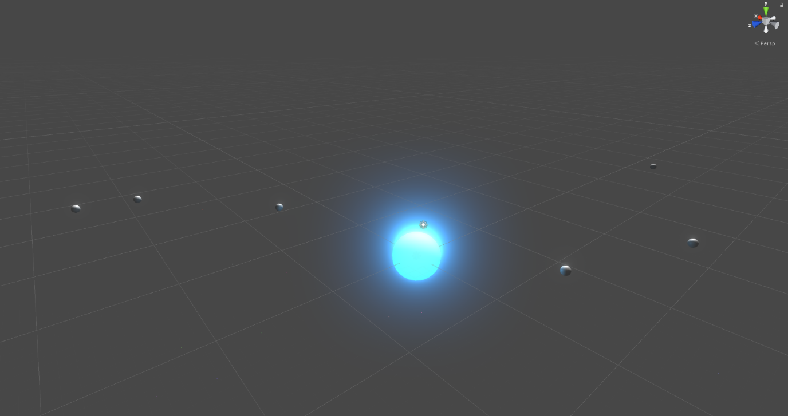

*Figure 3: Spawned planets orbiting around the star using the placement system.*

But the planets themselves were just boring gray spheres with zero variation between them, so the next problem to target was to provide variance to the planets.

Perlin noise from the LibNoise library was used with the goal of creating procedural atmospheres for the planets to help give them variance. The values and intensity of planetary atmospheres are also dictated by probability, which is augmented by the distance of the planets from the star. This effect was achieved by placing another sphere with a transparent material over the planet (With a slightly larger overall scale size) and adding Perlin noise to the material’s main texture. The immediate issue was that the texture created by the Perlin noise generator has no alpha channel and is opaque, meaning that we can no longer see the planet underneath (See figure 4).

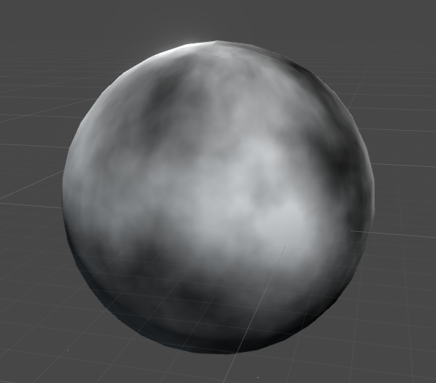

*Figure 4: A planet with the raw Perlin noise texture applied to it.*

This is solved by looping through all the pixels in the Perlin 2D noise texture and taking their colour and grayscale values, I then reapply the colour values back as normal but then apply the grayscale value to the alpha channel instead. Doing this means a value of 0 on the grayscale is black, which in the alpha channel means complete transparency leading to the desired effect (See figure 5).

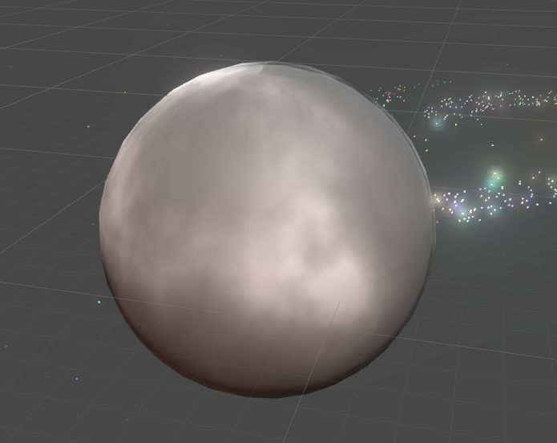

*Figure 5: A planet with the Perlin noise texture with the dark colour pixels phased out.*

While this is already looks like a planetary atmosphere, I wanted to push LibNoise further to see if it can make a more realistic looking cloud effect. I then realised that LibNoise had different forms of noise such as Billow, which had a wispier effect than Perlin Noise which looked more like clouds (See Figure 6).

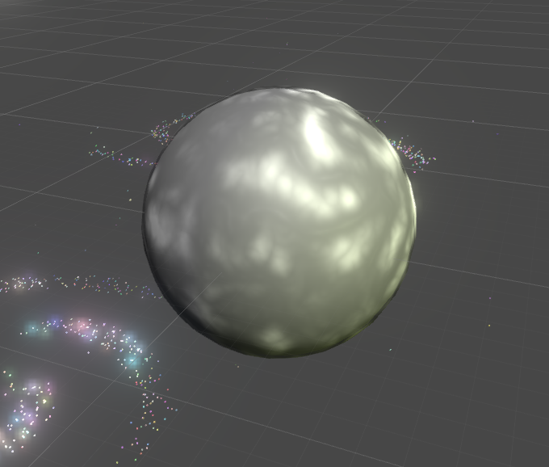

*Figure 6: Planet with Billow noise generated atmosphere.*

While this now looks acceptable for a planetary atmosphere, I was curious to combine the two noise generation methods together to see if it produced an even more realistic effect (See Figure 7).

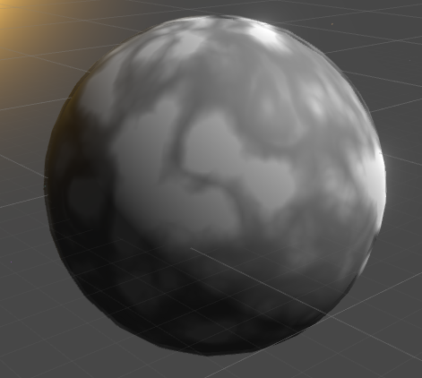

*Figure 7: Planetary atmosphere created with a combination of Billow and Perlin noises.*

This method of atmospheric creation results in a thicker, denser looking atmosphere which is effective on types of planets such as gas giants. Both techniques can be used to create different types of planets, based on the probability system which is augmented by a planet’s distance from the star of the solar system.

For the planet’s terrain, my original plan was to use noise to augment the vertices of the planets to give them terrain. I then realised that this approach is more likely unnecessary as the atmosphere of most planets will cover the terrain generated anyway. I settled on generating a 2D texture using Perlin noise and then changing their colour values based on their grayscale value, like the atmosphere system. Darker values would result in the planet’s oceans and the lighter values would result in land (See Figure 8).

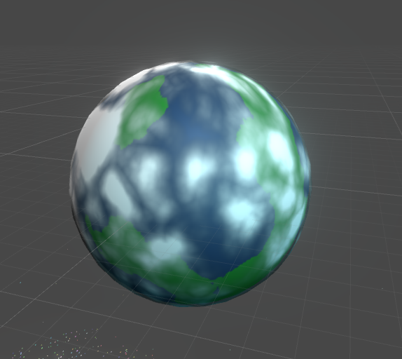

With this system now complete

Perlin cloud atmosphere based on distance, do multiple layers for thicker atmospheres, distance from star affects probability of size, terrain jaggedness, colour, moons. Galaxy stars brightness affected by how close they are from the centre of the galaxy.

Ships move along empty gameobject waypoints that transition them between planets and other items

Planets that are a certain distance away from the star will have a higher chance of getting asteroid rings

The first part of the assignment I decided to tackle was the generation of ships, I decided to start out with a small fighter using a blender model I have created as a base. A modular design was envisioned with multiple models of ship components such as weapons, wings, and engines being created in blender.

The fighter base is then created as a prefab with multiple empty game object “nodes” attached to it in predefined positions. These nodes make up all possible combinations of components that can be attached to the fighter base to make up the completed fighter. I did this because it greatly reduces the risk of erroneous results